Green Bridges a briefing note.

There is one feature of current political/economic life which trumps all others and that is the environment. Global warming and destruction of natural ecosystems are the consequences of doing nothing. The removal of diesel and petrol vehicles from our roads will see them replaced by electric vehicles, for the foreseeable future the demand for road transport is unlikely to diminish significantly but removing fossil fuels will help reduce global warming.

Destruction of our natural ecosystems proceeds apace destroying the viability of the natural environment and reducing carbon absorption by plants. So we need to stop the erosion of what we have, and importantly, seek to recover much of what we have lost. Ecosystems are complex but essentially require a blend of a variety of physical environments, animals, trees, lesser plants, invertebrates, etc. Significant efforts are going in to the creation of new wild life friendly areas some small, some large and of many different types. Water based marsh or fen, wild flower pastures by field or verge, wide hedgerows, woodland, parkland and areas intended for the specialist needs of wild life, e.g. Breckland and the Stone Curlew. The Suffolk Wildlife Trust, RSPB and others work on large projects, local organisations like Green Ixworth work on smaller scale operations and single householders wild lawns and parts of their gardens and provid nesting and window boxes all complementing both specific and general needs of nature.

On their own these various improvements can only provide limited benefits. To be really effective they need to be linked with common boundaries or wild life friendly corridors, hedges, green paths, waterways, etc. The animal kingdom relies on movement to access new feeding or breeding areas and with global warming, moving into less extreme climatic conditions.

Roads and railways are to nature as oceans, walls and fences and large waterways are to humans, obstacles to movement. This can be demonstrated by the remains of those animals that try to cross, littered along the roadside presenting a risk to drivers and a health hazard to all. Some waterways themselves can become routes for water based creatures. These obstacles to natural movement are now recognised by authorities and agencies as features which need to be breached for the sake of animals. The Highways Agency and Natural England have positive policies to encourage the removal of barriers to wild life and one of the most important is the provision of routes under or over busy roads.

There are a number of options based on nature's needs, cost and sites. Essentially under passes and culverts are only viable financially when building new roads and on an embankment. Bridges are more suitable in general and particularly when the road is at surface level or below. The above road option is a bridge which may span up to many tens of metres and have widths down to 8-10m. Larger animals deer, fox, rabbits, hares, badgers, hedgehogs, rodents are all happy to use well designed bridges.

Amphibians and insects are frequent users of bridges or tunnels and bats will use bridges providing there are natural canopies below which they can fly. Even some ground based birds such as partridge have used bridges rather than risk flying across busy roads.

Eco-ducts or Green Bridges have been constructed since the 1950's first in France and now all over Europe mostly over new roads. Now in the UK, not only on new roads. Recent examples include the Weymouth Bypass, A21 Scotney Castle and A556 in Cheshire.
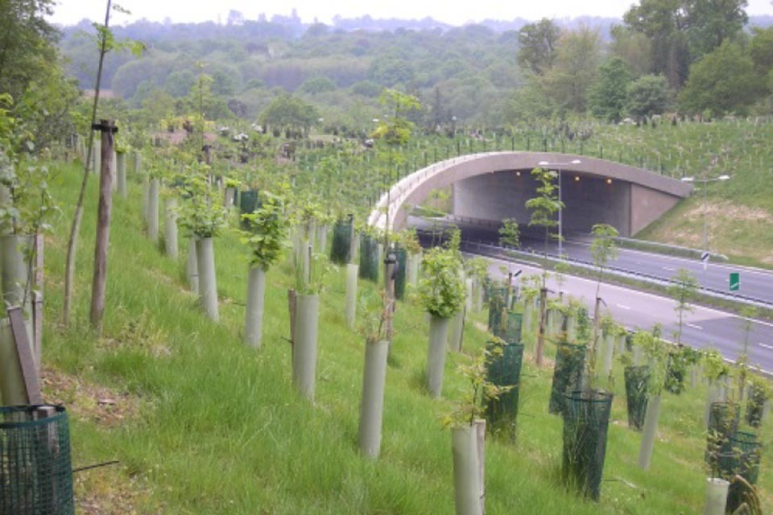

A21 dual use green bridge at Amberhurst
Note: the “green” part is behind the concrete foot/cycleway

Natural England guidance gives reasons for providing green bridges among which are “A mixed use green bridge can provide wider ecosystem services such as cultural services, allowing for recreational activities by joining up a severed path and providing cultural services in relation to aesthetic values and creating a sense of place.” (see below page 3).

The NPPF requirements for ”local planning authorities....planning positively for the creation, protection, enhancement and management of networks of biodiversity and green infrastructure.” (Page 3.)

It has been agreed for many years that a footbridge is required to re-link the two halves of Crown lane following the building of the A143 Ixworth by-pass. For some time the Parish Council, individuals and now Green Ixworth have sought to improve the natural environment in the village. Local Landowners are investing in environmental improvements on both sides of the road including the whole Wood Street area, with features such as new woodland, bird seed strips, beetle banks, hedgerow management, cover crops etc.

Green Ixworth has drawn up proposals for supporting and thickening the Hedge/woodland boundary on two sides of the settlement area and improving the river boundary as a wildlife corridor on the other sides. Persimmon has recently accepted the retention of the wild life corridors on three sides of their Crown Lane development in Ixworth following representations from Green ixworth. Green Ixworth has already made Crown Lane wildlife friendly with extensive planting and produce a wild life route between the bypass and the village, we would wish to see a link made across the bypass to link with the countryside. Crown Lane is a very well used route by walkers, cyclists and the disabled but for most only as far as the A143, crossing the road is extremely hazardous.

As the footbridge needs to be built, in part using developers funding from developing the Crown Lane site, a shared purpose bridge could be built rather than just the footbridge. The purposes: a pathway suitable for cyclists, disability scooters, prams and walkers/runners plus an additional strip with pasture and shrubs. The minimum width would need to be approx 2m for passing prams and cycles plus a minimum of 4-5m for a planted verge.

On the Ixworth side the bridge would connect to the wide planted tree and shrub barriers along the top of the road embankment and Crown Lane leading into the cemetery, the playing fields (soon to be improved for wildlife and villagers), village gardens and open green spaces. The NE side of the road is currently open fields with hedgerows but with wild flower pasture and woodland being planted within the next 18 months.

A well designed bridge can also have landscaping benefits.

There are many detailed considerations which might be incorporated including small ponds to facilitate the movement of amphibians, small mammals need water and providing additional wildlife habitat. The landing area for such a bridge need be only marginally greater than for a footbridge alone however for animals a funnel shaped entry is preferred.

References:

- Natural England Commissioned Report NECR181: A literature review 27th July 2015

http://publications.naturalengland.org.uk/file/6296975990325248

- Natural England Technical Guidance note 09/2015 Dec 2015.
https://landscapewpstorage01.blob.core.windows.net/www-landscapeinstitute;-org/2016/01/TGN9_15Green-Bridges-Guide_LI-300dpi.pdf

The second document is largely a distillation of the first and both provide examples largely UK and European based. Many examples also exist in North America.

RS-02/02/22

