Ukraine and our food supply.

Horrendous increase in prices of food stuffs and fossil fuels have resulted from Covid recovery, Brexit and now the war in Ukraine. The loss of 25% of the worlds exported grain and vegetable oil from Russia and Ukraine plus the sanctions on Russian coal, oil and gas have led traders buying ahead, from a smaller and uncertain source, to be sure of a supply, which results in disproportionate price rises. Most bulk food and fossil fuels are sold at global prices by the producers, wherever they are grown or produced. This has its most damaging impact in the developing world. In the UK it significantly increases inflation which impacts mostly on those with low incomes. Food and energy policy, in so far as it exists, has relied on being able to buy “cheaply” on the global market. We now see the folly of that both for food and energy.

However the crisis in food supply and energy were already with us before the current crises.

Food
For many years there has been a demand for a UK food policy which ensures food is reliably available and at affordable prices. This requires cooperation between Government, Farmers and food distributors. So far Government has refused to do more than suggest the Supermarkets are best able to ensure sufficient supplies. They naturally go for wherever the food is cheapest and fail to protect farmers in the UK often working to higher standards. This has driven many farmers globally to use the cheapest methods of production which over a decade or two can destroy the soils on which the future of humankind depends.
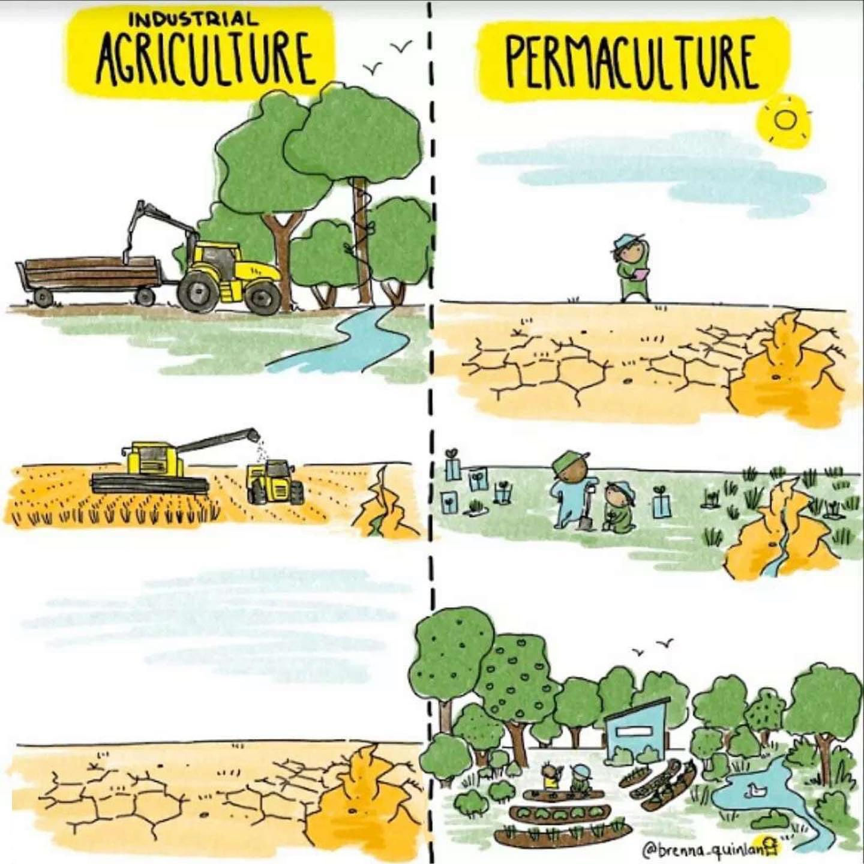
The cartoon is interesting as it poses two alternatives unfortunately neither of which is likely to feed the planet in the long run.

Increasingly farmers recognise the need to improve that which gives us good and continuous food – soil. Disturbance to the soil by ploughing, and loading it with fertilizers and pesticides destroy the natural processes which plants need to thrive. There are alternatives.

Much of the global grain and soya beans grown are for animal consumption. Much of the land in the UK is unsuitable for production of grains and other edible vegetation. Meat quality is better if the beasts are fed on growing vegetation such as grass and wild plants or what remains after harvesting grain, beet, etc. Traditional farming which did not use artificial fertilizers relied heavily on animal waste from their much smaller herds. The huge quantities of slurry from pigs and cattle, even when spread on fields damages the environment and our health because there is so much of it in a small area. It pollutes our water and produces ammonia which when in the air seriously damages human respiratory function.

Many farmers are now seeking to take a more sensible approach and learning from their forefathers. Mixed farming and rotation of crops with no-till in the fields, is increasingly being seen as a solution to many of the problems. Where it has been tried it minimises chemical inputs, uses varieties of animals which suit the environment instead of just maximising meat production and significantly reduces the consumption of diesel fuel.

We are not going to change overnight but we do need to speed up the process. This requires:

  - people to significantly reduce meat and dairy consumption.
  - government to:
- develop a long term plan with food producers to provide better certainty for their investment.
- continue to recognise the value of carbon reduction by increasing and improving natural biosystems.
- not sign trade deals with countries with lower food welfare standards.
- encourage UK production of grain and vegetables by judicious use of subsidies.
- recognise the higher costs of food and compensate the less well off for higher prices

The Ixworth and Stanton area are fortunate in having advanced, ecologically sound farmers in the vicinity but we are going to need many more.

More effort needs to be put in to produce a greater number of varieties of most food crops. For example almost all bananas are one cloned varity, “Cavendish”, which, in part because of global warming, are suffering from a disease unique to the variety. This does not just impact the consumer but also the producers in already disadvataged countries. When we look at grains and animals similar issues arise. Climate change resulting in higher temperatures and changes in humidity can cause reductions in productivity and thus supply. Land on which water shortage is already a problem are becoming impossible on which to grow crops.

This is why old, less productive varieties are preserved as they contain genes which, for example, enabel plants to grow in areas with salt in the groundwater which current varieties can not.

Energy

Many countries are seeking to use gas instead of coal as an interim, because it produces less carbon, so increasing demand for limited supplies. The UK Government suggests increasing supply as an answer to high prices. UK produced gas is sold at market price and thus to whoever pays the most, so any additional gas produced in the UK could still be sold anywhere in the world.

Also the UK does not have the gas reserves, to be fracked or otherwise, to make any noticable difference to global supplies. More importantly a license to drill exploration wells for gas or oil, will only see deliveries after 10 to 25 years. So the proposal could reqire £ billions of investment to deliver gas just as we will have stopped using fossil fuels by 2050.

Because the wind does not allways blow or the sun shine, Nuclear Power (NP) is being proposed to fill the gaps, for which NP is wholely unsuitable as it needs to run continuously. It does not like being shut down, which can take hours, and even longer to start up. From a decision being made in principle to design a station, to delivering power typically takes anything up to 25 years. It is many times more epensive than sustainable energy supplies like solar or wind.

What is really needed is more storage to maintain a steady supply of electricity regardless of the weather. The options include batteries, hydrogen, steam, compressed air, molten metals and salt, pumped storage and no doubt many others. We did have a large underground gas storage system off the Yorkshire coast but government decided 5 years ago that it was not prepared to pay for it as we could buy gas from abroad if needed!! What a clever decision!! No funding is being proposed for storage.

Using less energy is the most effective way of using less energy. Seems a daft statement and so obvious but insulating our older housing stock, which is almost all of it, would do just that and would have an immediate impact on our energy bills and is cheaper than alternatives. But there is no further encouragement for doing so. Green ixworth will be helping to identify your insulating needs in the late autumn, more information available then.

greenixworth.org.uk; would appreciate your thoughts on all these issues.

Why investment in vital net zero infrastructure is the best response to rising energy prices

