Green Ixworth
Home Energy Campaign

- Cheaper Measures: Efficiency and Fabric

“The cheapest energy is that which you don’t use”

Existing buildings can be adapted to improve their energy performance.

If your house has been assessed, you can look up an existing Energy Performance Certificate (EPC) at https://www.gov.uk/find-energy-certificate
This gives an assessment of the building’s performance as well as the potential improvements available.

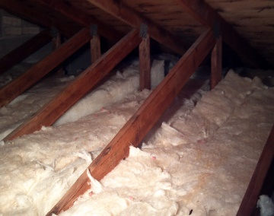
INSULATION
This Photo by Unknown Author is licensed under CC BY

Loft / Roof: potentially with sustainable material
e.g. treated sheep wool

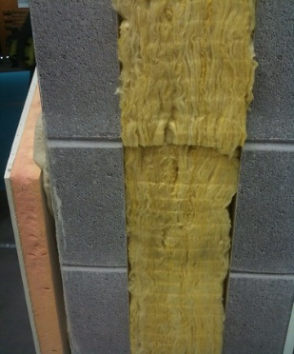
Walls: cavity, inside or outside 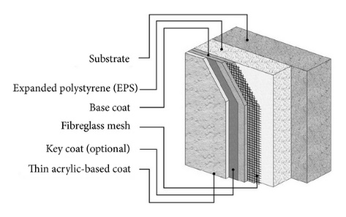
This Photo by Unknown Author is licensed under CC BY-SA-NC

Windows and Doors:

double- or triple- glazing | draft exclusion
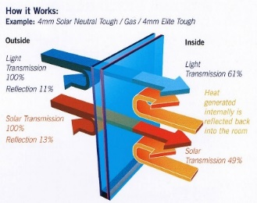
This Photo by Unknown Author is licensed under CC BY-SA
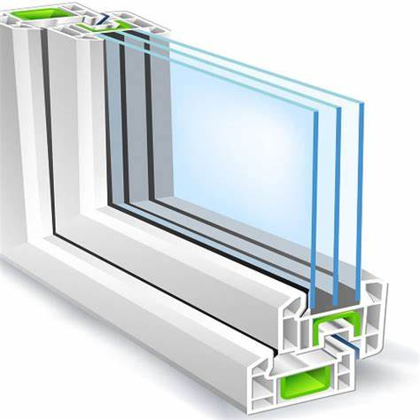 | 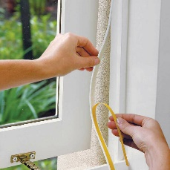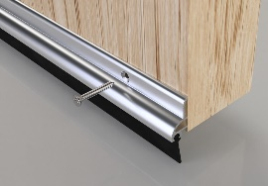

Lagging water tank and pipes:

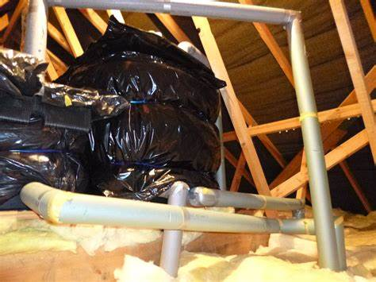 | 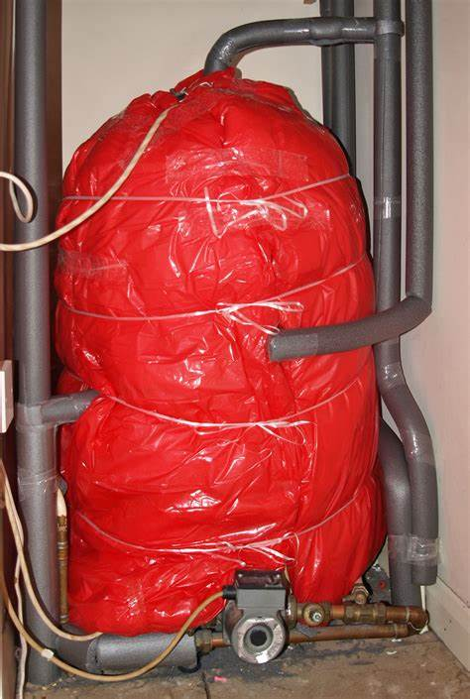

EFFICIENCY:

Use heat where and when it’s needed

- Reduce hot water usage: aerator shower heads and hot taps.

- Avoid using running hot water (dishwasher uses less)

- Turn off lights

- Turn off appliances: “vampire” devices on standby use a lot of energy over time.

- Smart sockets can tell you how much an appliance is using.

www.greenixworth.org

